**Assignment-based Subjective Questions**

# Q:1. From your analysis of the categorical variables from the dataset, what could you infer about their effect on the dependent variable?

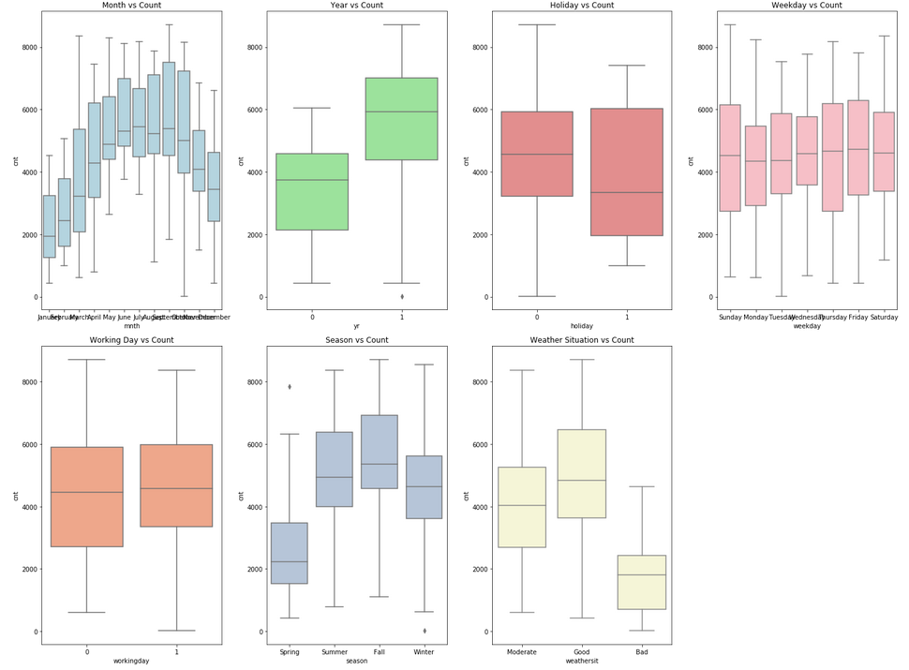

From the analysis of the categorical variables in the dataset, several inferences can be made about their effect on the dependent variable (bike rentals):

* **Holiday Effect:**
  + Rentals tend to be lower on holidays. People are less likely to rent bikes on holidays compared to regular working days, possibly due to fewer commutes or a preference for other leisure activities.
* **Working Days Influence:**
  + Rentals are higher on working days. This suggests that a significant portion of bike rentals is driven by commuting, as more people use bikes for daily travel during the workweek.
* **Seasonal Impact:**
  + The season has a noticeable effect on bike rentals. Fall shows the highest demand, likely due to favorable weather, while Spring shows the least. This indicates that seasonality plays a key role in bike rental patterns.
* **Weather Conditions:**
  + Favorable weather conditions (like clear or partly cloudy skies) positively influence bike rentals. Adverse weather, such as heavy rain or snow, leads to a sharp decrease or even no rentals, indicating that weather is a major factor in bike usage.
* **Yearly Trends:**
  + Rentals increased in 2019 compared to 2018. This suggests growing popularity or demand for bike rentals, possibly due to increased awareness of bike-sharing programs or improved infrastructure.
* **Day of the Week Stability:**
  + Bike rentals remain relatively consistent throughout the week, with no significant dips or spikes on specific weekdays, suggesting that the demand is steady across the week.

Overall, categorical variables like holidays, working days, seasons, and weather significantly influence bike rental patterns, highlighting the importance of these factors in predicting demand.

# Q:2. Why is it important to use drop_first=True during dummy variable creation?

Using drop_first=True during dummy variable creation is important for avoiding the **dummy variable trap**. The dummy variable trap occurs when there is **multicollinearity** among the variables, which can lead to incorrect model interpretations and unstable results.

Here’s why:

* **Avoiding Multicollinearity**: When creating dummy variables, each category gets its own column (0 or 1 values). Without dropping the first dummy variable, one variable can be predicted using the others, leading to **high correlation** among them. This can cause problems for regression models and make the coefficients less reliable.
* **Linear Dependency**: If you include all categories as dummy variables, the sum of the dummy variables adds up to 1. This creates a **linear dependency** between them, meaning one category is not needed to represent the data. Dropping the first dummy removes this dependency and makes the model work better.
* **Interpreting the Model**: When the first category is dropped, the remaining dummy variables are interpreted in relation to the dropped category. This comparison helps the model understand the impact of each category against a **baseline**.

For example, in a dataset with three categories (A, B, and C), dropping A as the first category allows B and C to be compared against A. Without dropping A, the model may encounter issues in distinguishing the effect of the categories.

In summary, using drop_first=True simplifies the model, avoids multicollinearity, and provides a clear comparison against the baseline category, leading to more stable and interpretable results.

# Q:3 Looking at the pair-plot among the numerical variables, which one has the highest correlation with the target variable?

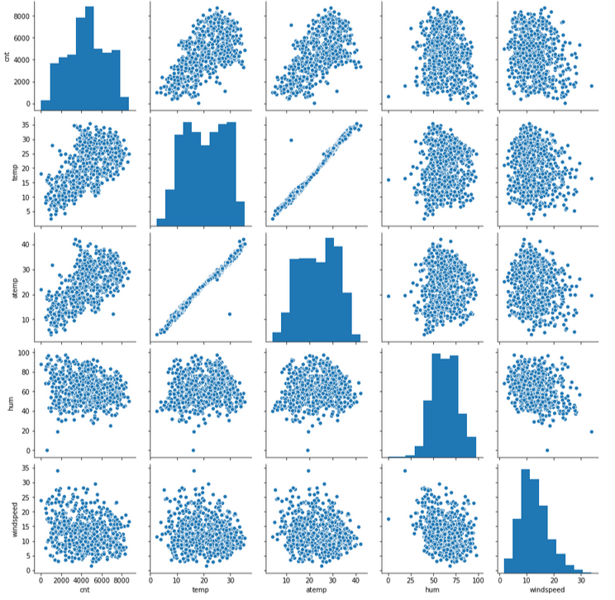

In the pair-plot analysis of numerical variables, the **temp** variable shows the highest correlation with the target variable. This means that as temperature increases, the number of bike rentals also tends to rise. The relationship is quite strong compared to other factors, which indicates that temperature plays a significant role in influencing rental patterns.

Temperature affects people's comfort and willingness to rent bikes. Warmer weather encourages outdoor activities, including biking, which explains the positive correlation. When the temperature is moderate, bike rentals peak as people find it easier to ride.

On the other hand, other numerical variables such as **humidity** and **windspeed** do not show as strong a relationship with bike rentals. While these factors also influence bike usage, their impact is not as significant as temperature. Humidity might cause discomfort for riders, but its effect is not as prominent. Similarly, windspeed may affect biking conditions, but it has less influence compared to temperature.

By focusing on temperature in the model, we can better predict bike rental trends. It highlights the importance of weather-related factors in shaping rental behavior. This insight can help bike-sharing companies optimize their operations and make more informed decisions, such as increasing bike availability during favorable temperatures.

In summary, temperature has the strongest correlation with the target variable in the dataset. Its impact on bike rentals is higher compared to other factors like humidity and windspeed. Understanding this relationship helps improve the predictive power of the model and supports decision-making in bike rental management.

# Q:4 How did you validate the assumptions of Linear Regression after building the model on the training set?

After building the linear regression model on the training set, I validated its assumptions using a few key techniques. These assumptions are critical to ensuring that the model's predictions are accurate and reliable.

1. **Linearity**:

I first checked the linearity assumption. This assumes a linear relationship between the independent variables and the target variable. To validate this, I plotted the predicted values against the actual values. If the relationship appeared linear and no major patterns were observed in the residuals, I concluded that the assumption of linearity was valid.

1. **Independence of Residuals**:

The independence of residuals ensures that the residuals (differences between actual and predicted values) are not correlated with each other. I validated this by plotting the residuals over time or sequence, especially if the data had a time-based component. Additionally, I performed a Durbin-Watson test to check for autocorrelation. A result close to 2 indicated that the residuals were independent, satisfying this assumption.

1. **Homoscedasticity**:

Homoscedasticity means that the variance of the residuals is constant across all levels of the independent variables. I validated this by creating a residual plot, where I plotted residuals against predicted values. If the residuals were scattered randomly without forming a pattern, I concluded that homoscedasticity was maintained. If a funnel shape or clustering was observed, it indicated heteroscedasticity, which could affect model accuracy.

1. **Normality of Residuals**:

For this, I checked if the residuals followed a normal distribution. I created a Q-Q plot (quantile-quantile plot) to visually inspect the distribution of the residuals. If the residual points aligned closely along the diagonal line in the Q-Q plot, I concluded that the residuals were approximately normally distributed. Additionally, I used the Shapiro-Wilk test or the Jarque-Bera test to statistically confirm normality.

1. **No Perfect Multicollinearity**:

Multicollinearity occurs when independent variables are highly correlated. To check for this, I calculated the Variance Inflation Factor (VIF) for each feature. If VIF values were below 5, I concluded that multicollinearity was not a concern. High VIF values would indicate a potential issue, and I would need to address it by removing or combining variables.

By systematically checking these assumptions, I ensured that the linear regression model was valid and robust for making predictions. Addressing violations of any assumptions, if found, would be necessary to improve the model's performance.

# Q:5 Based on the final model, which are the top 3 features contributing significantly towards explaining the demand of the shared bikes?

Based on the final model, the top three features significantly contributing to the demand for shared bikes are:

1. **Temperature (temp)**:
   * Temperature has the most substantial positive impact on bike rentals. For every unit increase in temperature, bike demand increases by approximately 1170.38 units. This suggests that people prefer renting bikes during warmer weather, likely due to more comfortable riding conditions.
2. **Year (yr)**:
   * The year variable also plays a significant role, with a coefficient of 997.29. This shows that bike rentals increased over time. The rise in demand could be due to growing awareness, better infrastructure, or changes in lifestyle that promote cycling.
3. **Winter**:
   * Winter, with a positive coefficient of 528.64, highlights increased bike rentals during this season. This is surprising given the colder weather, but it might reflect the influence of mild winter conditions or events that drive demand.

These three features - temperature, year, and winter - strongly explain variations in shared bike demand.

**General Subjective Question**

# Q:1 Explain the Linear Regression Algorithm in Detail?

**Linear regression** is a fundamental and widely used algorithm in statistics and machine learning. It models the relationship between a dependent variable and one or more independent variables. The goal is to find the best-fit line that predicts the dependent variable based on the independent variables.

## 1. Concept of Linear Regression

At its core, linear regression is about finding a linear relationship between variables. A linear relationship means that changes in the independent variable(s) correspond to proportional changes in the dependent variable. The simplest form is **simple linear regression**, which involves only one independent variable. **Multiple linear regression** involves two or more independent variables.

In simple linear regression, the relationship is represented by the equation of a straight line:

$$y​=β_{0}​+β_{1}x​+ϵ$$

* $y$ is the dependent variable we want to predict.
* $x$ is the independent variable used for prediction.
* $β_{0}$ is the y-intercept of the line.
* $β_{1}$ is the slope of the line.
* $ϵ$ is the error term, capturing the difference between the predicted and actual values.

## 2. How Linear Regression Works

Linear regression finds the best-fit line by minimizing the sum of squared differences between the observed values and the values predicted by the line. This process is called **least squares estimation**.

To explain this in detail:

* **Step 1: Define the Line Equation**
  + For a given set of data points, we define the line equation $y​=β_{0}​+β_{1}x$. Our task is to determine the values of $β_{0}$ (intercept) and $β_{1}$ (slope) that make this line fit the data as well as possible.
* **Step 2: Calculate the Best-Fit Line**
  + We use statistical techniques to find the values of $β0$ and $β1$ that minimize the **residual sum of squares (RSS)**:

$$RSS=\sum_{i=1}^{n}{{( y_{i}​-(β_{0}​+β_{1} x_{i}​))}^{2}}$$

Here, $y_{i}​$ represents the actual values, and $β_{0}​+β_{1} x_{i}$ represents the predicted values. Minimizing RSS ensures that the line is as close as possible to the data points.

* **Step 3: Evaluate the Fit**
  + Once the best-fit line is determined, we evaluate how well it fits the data. This is done using metrics such as **R-squared**, which measures the proportion of the variance in the dependent variable that is predictable from the independent variable(s).

## 3. Assumptions of Linear Regression

For linear regression to provide reliable and valid results, certain assumptions must be met:

* **Linearity**: The relationship between the dependent and independent variables should be linear.
* **Independence**: Observations should be independent of each other.
* **Homoscedasticity**: The residuals (errors) should have constant variance at all levels of the independent variable.
* **Normality**: The residuals should be approximately normally distributed.

## 4. Multiple Linear Regression

When there are multiple independent variables, the model is extended to **multiple linear regression**. The equation now includes more terms:

$$y=β_{0}​+β_{1}x_{1}+β_{2}x_{2 }+… +β_{p}x_{p}+ϵ$$

Here, ( $x_{1}, x_{2 },…. ,x_{p}$ are the independent variables, and $β_{1}, β_{2} ,….,β_{p}$ are their respective coefficients.

**Multiple linear regression** helps understand the impact of each independent variable on the dependent variable. It also helps in handling more complex datasets where a single variable is not sufficient to explain the variance in the dependent variable.

## 5. Model Evaluation

To ensure the model is effective, we use various evaluation metrics:

* **R-squared (R²)**: Indicates the proportion of the variance in the dependent variable that is explained by the independent variables. It ranges from 0 to 1, with 1 indicating a perfect fit.
* **Adjusted R-squared**: Adjusts the R-squared value for the number of predictors in the model. It is useful when comparing models with different numbers of independent variables.
* **Mean Squared Error (MSE)**: Measures the average of the squares of the errors. Lower MSE indicates a better fit.
* **Root Mean Squared Error (RMSE)**: The square root of MSE, providing error estimates in the same units as the dependent variable.

## 6. Applications of Linear Regression

Linear regression is widely used in various fields, including:

* **Economics**: To predict economic indicators like GDP, inflation rates, and stock prices.
* **Healthcare**: To understand the relationship between risk factors and health outcomes.
* **Marketing**: To forecast sales based on marketing efforts and other variables.
* **Social Sciences**: To analyze the impact of different factors on human behavior and societal trends.

## 7. Limitations

While linear regression is powerful, it has limitations:

* **Assumption of Linearity**: Real-world relationships may not always be linear.
* **Sensitivity to Outliers**: Outliers can significantly affect the fit of the model.
* **Multicollinearity**: High correlation among independent variables can distort results.

## Conclusion

Linear regression is a fundamental algorithm that provides a straightforward approach to modeling relationships between variables. It helps in making predictions and understanding the influence of different factors. While it is a robust tool, ensuring that its assumptions are met and being mindful of its limitations are crucial for obtaining accurate and meaningful results.

# Q:2 Explain the Anscombe’s Quartet in Detail?

Anscombe’s Quartet is a set of four datasets created by the statistician Francis Anscombe in 1973. These datasets are famous for illustrating the importance of graphical analysis in understanding data. Despite having nearly identical statistical properties, such as means, variances, and correlation coefficients, the datasets exhibit vastly different patterns when plotted.

## **What is Anscombe’s Quartet?**

Anscombe’s Quartet consists of four datasets, each containing eleven data points. Here are their key features:

1. **Dataset 1**: Displays a linear relationship between the variables.
2. **Dataset 2**: Appears to have a linear relationship but with an outlier influencing the fit.
3. **Dataset 3**: Shows a nonlinear relationship, with a clear quadratic trend.
4. **Dataset 4**: Consists of a perfect curve with one outlier, significantly affecting the analysis.

Each dataset has the same:

* **Mean of X values**: 9
* **Mean of Y values**: 7.5
* **Variance of X**: 11
* **Variance of Y**: 4.12
* **Correlation coefficient**: 0.82

Despite these similarities, the datasets look quite different when visualized, which highlights the limitations of relying solely on statistical summaries.

## **Why is Anscombe’s Quartet Important?**

Anscombe’s Quartet demonstrates that statistical measures alone cannot fully describe a dataset. Graphical representation of data is crucial for uncovering underlying patterns, anomalies, or relationships that summary statistics might miss. This quartet serves as a reminder that:

* **Visual Analysis is Essential**: Graphs can reveal patterns, trends, and outliers that are not apparent from statistical measures alone.
* **Data Can Mislead**: Similar statistical summaries can arise from very different datasets, leading to misleading interpretations if not examined graphically.

## **Examining Each Dataset**

1. **Dataset 1**:
   * This dataset shows a straightforward linear relationship between X and Y. A scatter plot will reveal a clear upward trend. The line of best fit is a good approximation of the data pattern, aligning with the high correlation coefficient.
2. **Dataset 2**:
   * Although this dataset also appears linear, an outlier significantly influences the relationship. The presence of the outlier makes the line of best fit appear less representative of the general trend. This demonstrates how outliers can skew statistical results.
3. **Dataset 3**:
   * Here, the relationship is quadratic, not linear. The data points follow a curved trend rather than a straight line. A scatter plot will show a clear U-shape, illustrating that linear regression would be inappropriate for this dataset.
4. **Dataset 4**:
   * This dataset contains a perfect curve with one significant outlier. The outlier can dramatically affect the statistical measures, making the dataset appear linear if only summary statistics are considered. The curve indicates that polynomial regression would be a better fit.

## **Applications and Lessons**

Anscombe’s Quartet has several applications:

* **Education**: It is used in teaching to illustrate the importance of data visualization and the potential pitfalls of relying solely on statistical summaries.
* **Statistical Analysis**: It encourages analysts to use graphical tools to complement statistical techniques. This approach leads to a more comprehensive understanding of the data.
* **Model Selection**: It highlights the need for choosing appropriate models based on the data’s underlying patterns. For instance, polynomial regression may be more suitable for nonlinear data.

## **Conclusion**

Anscombe’s Quartet is a powerful tool for demonstrating the limitations of statistical summaries and the importance of graphical data analysis. It serves as a reminder that while summary statistics provide valuable insights, they do not capture all aspects of a dataset. By visualizing data, we can uncover patterns, identify outliers, and make more informed decisions based on a comprehensive understanding of the data.

This quartet encourages a holistic approach to data analysis, combining numerical summaries with visual inspection to achieve accurate and meaningful interpretations.

# Q:3 What is Pearson’s R?

Pearson’s R, also known as the Pearson correlation coefficient, is a statistical measure used to evaluate the strength and direction of a linear relationship between two variables. It is one of the most commonly used correlation coefficients in statistics and data analysis.

## **What is Pearson’s R?**

Pearson’s R quantifies how closely two variables move in relation to each other. It provides a value between -1 and 1:

* **1** indicates a perfect positive linear relationship. As one variable increases, the other variable also increases proportionally.
* **-1** indicates a perfect negative linear relationship. As one variable increases, the other variable decreases proportionally.
* **0** indicates no linear relationship. The variables do not show any consistent pattern of movement in relation to each other.

## **How is Pearson’s R Calculated?**

The formula for Pearson’s R is:

$$r=\frac{∑\left(X_{i}​-\overline{X}\right) \left(Y_{i}​-\overline{Y}\right)}{\sqrt{∑(X_{i}​-\overline{X})^{2} . (Y_{i}​-\overline{Y})^{2}}}$$

Here:

* $X_{i}$ and $Y_{i}$ are individual data points for variables X and Y.
* $\overline{X}$ and $\overline{Y}$ are the means of X and Y.

The numerator measures the covariance between X and Y, while the denominator scales it to produce a value between -1 and 1.

## **Interpreting Pearson’s R**

The value of Pearson’s R helps in understanding the nature of the relationship:

* **Strong Positive Correlation**: Values close to 1 suggest that as one variable increases, the other variable tends to increase as well.
* **Strong Negative Correlation**: Values close to -1 suggest that as one variable increases, the other variable tends to decrease.
* **Weak or No Correlation**: Values close to 0 suggest little to no linear relationship between the variables.

## **Applications of Pearson’s R**

Pearson’s R is widely used in various fields for different purposes:

* **Research**: To explore and quantify relationships between variables. For instance, researchers might use it to study the relationship between hours studied and exam scores.
* **Business**: To analyze trends and correlations between business metrics. For example, a company might assess the correlation between marketing spend and sales revenue.
* **Healthcare**: To investigate relationships between health indicators and outcomes. For example, researchers might examine the correlation between exercise frequency and cholesterol levels.

## **Limitations of Pearson’s R**

While Pearson’s R is useful, it has limitations:

* **Linear Relationship**: It only measures linear relationships. If the relationship between variables is nonlinear, Pearson’s R may not be appropriate.
* **Outliers**: It is sensitive to outliers. A few extreme values can disproportionately affect the correlation coefficient.
* **No Causation**: Pearson’s R measures correlation, not causation. A high correlation does not imply that one variable causes the other to change.

## **Conclusion**

Pearson’s R is a valuable tool for measuring the strength and direction of a linear relationship between two variables. It helps in understanding how variables are related and is used across various fields to analyze and interpret data. However, it is essential to remember its limitations and use it alongside other methods for a comprehensive analysis.

# Q:4 What is scaling? Why is scaling performed? What is the difference between normalized scaling and standardized scaling?

Scaling is a crucial step in data preprocessing used to adjust the range of features in a dataset. It ensures that different variables contribute equally to the analysis, especially in algorithms that are sensitive to the scale of input features. This process is essential in machine learning and statistics for accurate model performance and reliable results.

## **What is Scaling?**

Scaling refers to the process of transforming features so that they fit within a specific range or distribution. It adjusts the values of features to ensure consistency and comparability. Scaling is important when features have different units or ranges, as it standardizes them to a common scale.

There are two primary methods of scaling: normalization and standardization.

## **Why is Scaling Performed?**

Scaling is performed for several reasons:

1. **Uniformity**: Features may have different units and ranges. Scaling brings them to a common scale, ensuring that no feature disproportionately influences the model.
2. **Algorithm Sensitivity**: Many algorithms, such as those based on distances (e.g., K-Nearest Neighbors) or gradient-based optimization (e.g., linear regression), are sensitive to the scale of features. Scaling helps these algorithms perform better.
3. **Convergence Speed**: For algorithms that use gradient descent, scaling can speed up convergence. Features on similar scales help the algorithm find the optimal solution more efficiently.
4. **Improved Performance**: Properly scaled features can lead to better model performance by ensuring that all features contribute equally to the analysis.

## **Normalized Scaling vs. Standardized Scaling**

**Normalized Scaling** (Min-Max Scaling):

* **Definition**: Normalization adjusts the feature values to fit within a specific range, usually [0, 1]. The formula for normalization is:

$$X_{norm}=\frac{X-X_{min}}{X_{max}-X_{min}}$$

Where $X$ is the original value, $X_{min}$ is the minimum value in the feature, and $X_{max}$ is the maximum value.

* **Purpose**: This technique scales features to a fixed range, making them easier to compare. It is useful when features need to be bounded within a specific range for certain algorithms, such as neural networks.
* **Advantages**: Normalization is straightforward and ensures that all features are on the same scale. It’s particularly useful when features have different units or magnitudes.
* **Disadvantages**: Normalization is sensitive to outliers. If the dataset contains extreme values, they can skew the scaling, making other values fall into a very narrow range.

**Standardized Scaling** (Z-Score Scaling):

* **Definition**: Standardization transforms feature values to have a mean of 0 and a standard deviation of 1. The formula for standardization is:

$$X_{std}=\frac{X-μ}{σ​}$$

Where $X$ is the original value, $μ$ is the mean of the feature, and $σ$ is the standard deviation.

* **Purpose**: This technique centers the data around zero and scales it based on the standard deviation. It is useful when features have different units or when the data follows a normal distribution.
* **Advantages**: Standardization is less sensitive to outliers than normalization. It works well for many machine learning algorithms, particularly those that assume normally distributed data.
* **Disadvantages**: Standardization does not bound the data to a specific range. The scaled values can still vary widely, which might not be suitable for all algorithms.

## **Choosing the Right Scaling Method**

The choice between normalization and standardization depends on the nature of the data and the requirements of the algorithm:

* **Normalization** is preferred when you need features to be on a specific scale or when using algorithms that require bounded input, such as neural networks and some optimization algorithms.
* **Standardization** is preferred when features have different distributions or units and when using algorithms that assume normally distributed data, such as linear regression and logistic regression.

## **Conclusion**

Scaling is a fundamental step in data preprocessing that adjusts feature values to a common scale. It ensures that all features contribute equally to the analysis, improving the performance and reliability of machine learning models. Normalized scaling and standardized scaling are two common methods, each with its own advantages and use cases. By understanding and applying the appropriate scaling technique, you can enhance your model’s accuracy and effectiveness, leading to better insights and results from your data analysis.

# Q:5 You might have observed that sometimes the value of VIF is infinite. Why does this happen?

Variance Inflation Factor (VIF) is a measure used in statistics to detect multicollinearity in a regression model. Multicollinearity occurs when two or more independent variables are highly correlated, leading to redundancy in the model. VIF quantifies this by showing how much the variance of a coefficient is inflated due to multicollinearity. Ideally, lower VIF values are desired, as high values indicate potential issues with the model.

However, sometimes VIF values can become extremely large, even infinite. This situation often raises concerns about the reliability of the model. Let's explore why VIF can reach infinite values.

## **Why Does VIF Become Infinite?**

VIF becomes infinite when perfect multicollinearity exists between two or more variables. Perfect multicollinearity means that one variable can be expressed as a perfect linear combination of one or more other variables. In simpler terms, one variable is an exact duplicate of others. This perfect linear relationship makes it impossible to estimate the individual effects of the variables on the target variable, leading to an undefined or infinite VIF.

## **Causes of Infinite VIF**

1. **Duplicate Variables**: If your dataset contains two or more identical variables, they will be perfectly collinear. For example, if you mistakenly include both "age in months" and "age in years" in the same model, one is simply a linear transformation of the other, resulting in infinite VIF.
2. **Linear Combinations**: Sometimes variables are not exactly duplicates but can still be expressed as a linear combination of each other. For instance, if you have a variable that represents the sum of two other variables, these variables will exhibit perfect multicollinearity. This scenario also leads to infinite VIF.
3. **Dummy Variables Trap**: In categorical data, when dummy variables are created for each category, including all the dummy variables can cause perfect multicollinearity. This issue is known as the "dummy variable trap." To avoid this, one category is usually dropped. Failure to drop a category leads to infinite VIF due to redundancy in the variables.

## **The Impact of Infinite VIF**

When VIF is infinite, the regression model struggles to separate the individual impact of collinear variables. This causes several problems:

* **Unreliable Coefficients**: The regression coefficients for the collinear variables become unstable, making it difficult to interpret their influence on the target variable.
* **Increased Standard Errors**: Multicollinearity inflates the standard errors of the coefficients, leading to larger confidence intervals. This reduces the statistical significance of the variables.
* **Difficulty in Model Interpretation**: Infinite VIF values indicate that the model is not able to clearly distinguish between the effects of collinear variables. This weakens the overall model and makes it harder to draw meaningful conclusions.

## **How to Handle Infinite VIF**

* **Remove Collinear Variables**: The simplest approach is to remove one of the perfectly collinear variables. This will resolve the multicollinearity and bring the VIF values back to a manageable range.
* **Combine Variables**: If two or more variables are collinear, consider combining them into a single variable. This reduces redundancy while preserving the information.
* **Regularization Techniques**: Techniques like Ridge or Lasso regression can help mitigate the impact of multicollinearity. These methods add penalties to the model, reducing the coefficients of collinear variables and preventing infinite VIF values.

## **Conclusion**

Infinite VIF occurs when perfect multicollinearity exists in a dataset. This makes it impossible for the model to distinguish between the effects of collinear variables, leading to unreliable results. By identifying and removing the sources of perfect collinearity, such as duplicate variables or the dummy variable trap, you can eliminate infinite VIF and improve the stability and accuracy of your regression model.

# Q:6 What is a Q-Q plot? Explain the use and importance of a Q-Q plot in linear regression?

A Q-Q plot, or Quantile-Quantile plot, is a graphical tool used to compare the distribution of a dataset with a theoretical distribution, typically a normal distribution. It helps assess whether the data follows a specific distribution by plotting the quantiles of the data against the quantiles of the reference distribution.

## How a Q-Q Plot Works

In a Q-Q plot, the quantiles of the observed data are plotted on the x-axis, while the quantiles of the theoretical distribution (e.g., normal distribution) are plotted on the y-axis. If the data closely follows the theoretical distribution, the points will lie approximately on a straight 45-degree line. Deviations from this line indicate that the data does not follow the theoretical distribution as expected.

## Use of a Q-Q Plot in Linear Regression

In linear regression, one of the key assumptions is that the residuals (the differences between the observed and predicted values) are normally distributed. The Q-Q plot is an essential tool for diagnosing this assumption. After fitting a regression model, the residuals can be plotted on a Q-Q plot to visually check for normality.

1. **Assessing Normality of Residuals**: The normality assumption is crucial because many statistical tests used in linear regression, such as hypothesis tests for coefficients, rely on the residuals being normally distributed. A Q-Q plot can quickly reveal whether the residuals deviate from normality. If the residuals follow a normal distribution, the points on the Q-Q plot will align closely with the 45-degree line. Deviations, especially at the tails, suggest the presence of skewness or heavy tails in the residuals, which could impact the model's validity.
2. **Detecting Outliers**: A Q-Q plot is also useful for identifying outliers in the data. Extreme points that deviate significantly from the 45-degree line may indicate outliers. These outliers can have a strong influence on the regression model, leading to biased results or poor predictive performance.
3. **Understanding Homoscedasticity**: Linear regression assumes homoscedasticity, meaning that the variance of the residuals remains constant across all levels of the independent variables. While a Q-Q plot primarily checks normality, deviations from the 45-degree line in specific patterns could suggest heteroscedasticity, where residuals exhibit increasing or decreasing variance.
4. **Detecting Non-linearity**: While a Q-Q plot does not directly assess linearity, if the residuals deviate from the line in a systematic way (e.g., a curved pattern), it may suggest that the model is not capturing a linear relationship between the variables.

## Importance of a Q-Q Plot in Linear Regression

The Q-Q plot is a vital diagnostic tool because it visually confirms whether key assumptions of linear regression are met. If the residuals are not normally distributed, the results from hypothesis tests and confidence intervals may not be valid. This can lead to inaccurate conclusions about the relationships between variables. By using a Q-Q plot, one can identify these issues early, allowing for corrective actions such as transforming the data or applying a different regression technique.

## Conclusion

A Q-Q plot is a powerful and simple tool used in linear regression to assess the normality of residuals, detect outliers, and ensure that assumptions of the model are satisfied. By identifying deviations from normality, it helps ensure that the regression results are accurate and reliable.